Makata Mpho
Week 9 practical

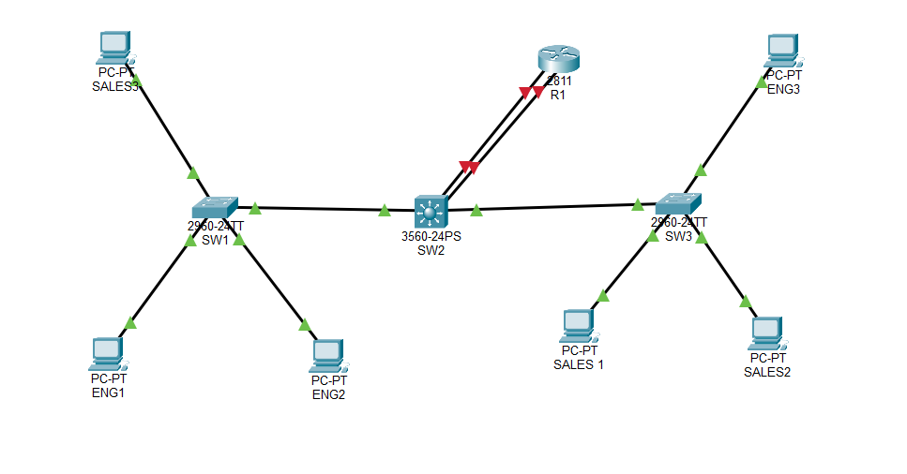
89.
SW1 Client
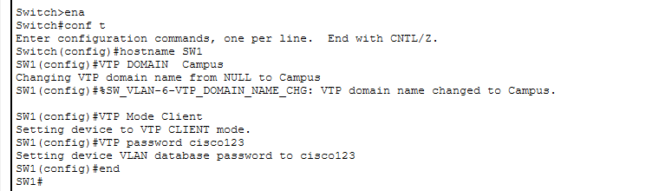

SW3 Client
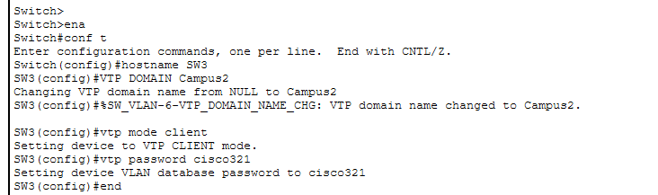
SW2
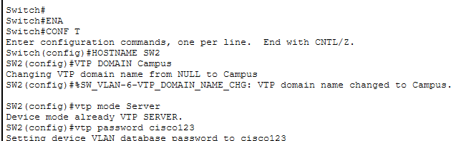

90.
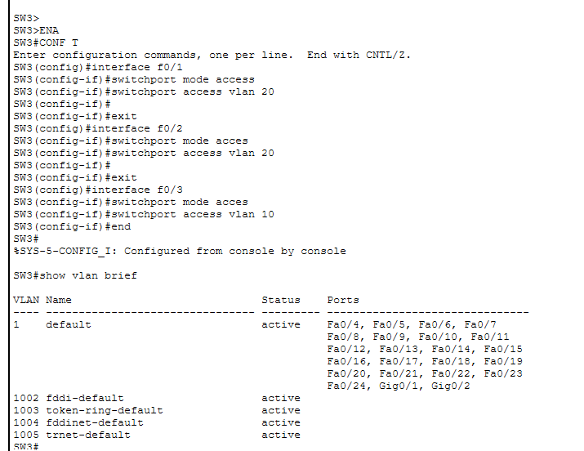
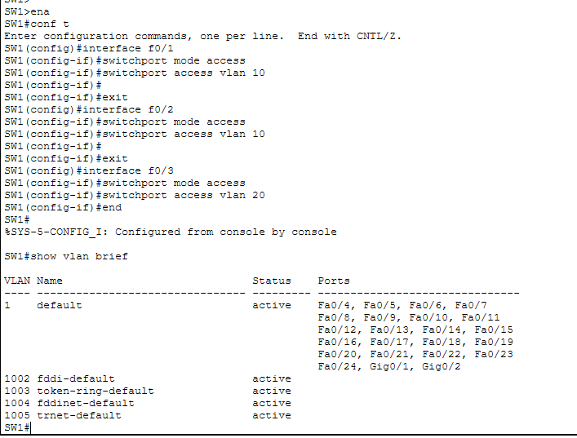
91.
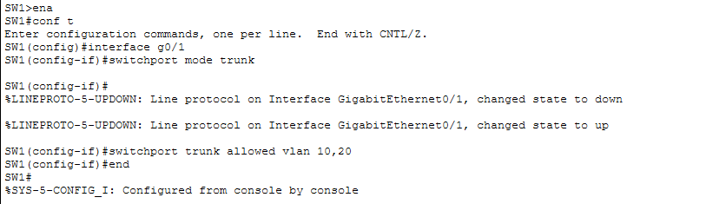

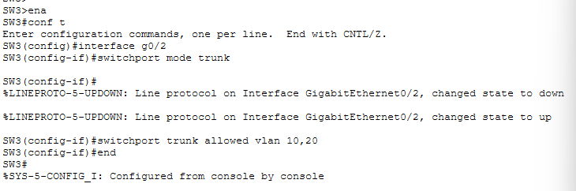
92.
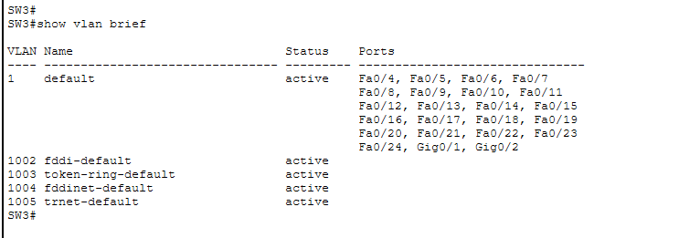

93.
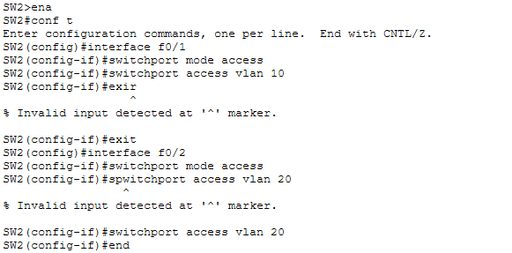
R1
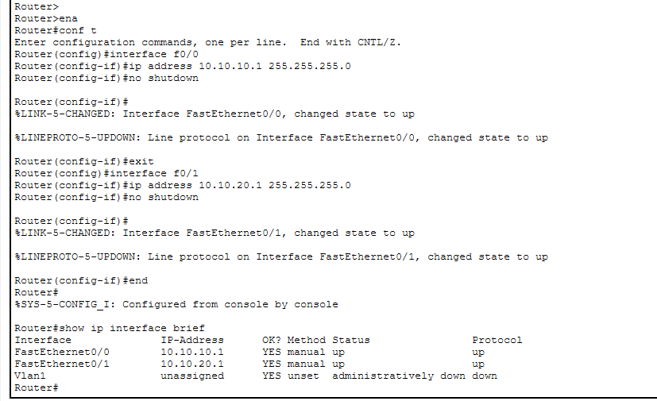

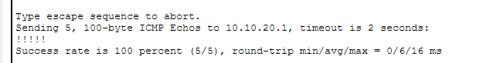
94.
Trunk port
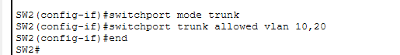
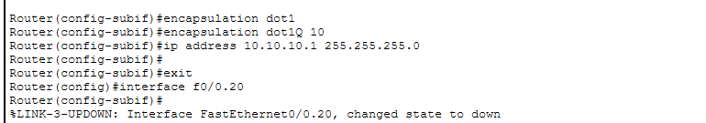
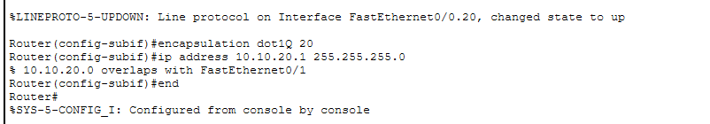

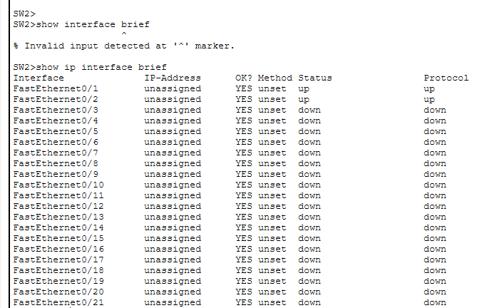

96. Option 3, Layer 3 switching, scales best because it provides high-speed hardware-based inter-VLAN routing, supports many VLANs through SVIs, and avoids the physical-interface limitations of separate router interfaces and the potential trunk bottleneck of router-on-a-stick.

Bonus After all Configurations
